UNITED STATES
SECURITIES AND EXCHANGE COMMISSION
WASHINGTON, D.C. 20549
_____________
FORM 8-K
______________
CURRENT REPORT PURSUANT TO SECTION 13 OR 15(d) OF THE SECURITIES EXCHANGE ACT OF 1934

Date of Report (Date of earliest event reported) September 11, 2026

ARMOUR Residential REIT, Inc.
(Exact Name of Registrant as Specified in Its Charter)

Maryland |  |  | 001-34766 |  |  | 26-1908763
(State or Other Jurisdiction  of Incorporation) |  |  | (Commission File Number) |  |  | (I.R.S. Employer Identification No.)
3001 Ocean Drive, Suite 201
Vero Beach, |  |  | Florida |  |  |  |  |  | 32963
(Address of Principal Executive Offices) |  |  |  |  |  |  |  |  | (Zip Code)

(772) 617-4340
(Registrant’s Telephone Number, Including Area Code)

n/a
(Former Name or Former Address, if Changed Since Last Report)

Check the appropriate box below if the Form 8-K filing is intended to simultaneously satisfy the filing obligation of the registrant under any of the following provisions (see General Instruction A.2. below):
☐ Written communications pursuant to Rule 425 under the Securities Act (17 CFR 230.425)
☐ Soliciting material pursuant to Rule 14a-12 under the Exchange Act (17 CFR 240.14a-12)
☐ Pre-commencement communications pursuant to Rule 14d-2(b) under the Exchange Act (17 CFR 240.14d-2(b))
☐ Pre-commencement communications pursuant to Rule 13e-4(c) under the Exchange Act (17 CFR 240.13e-4(c))
Securities registered pursuant to Section 12(b) of the Act:
Title of Each Class |  |  |  |  |  | Trading symbols |  |  |  |  |  | Name of Exchange on which registered
Preferred Stock, 7.00% Series C Cumulative Redeemable |  |  |  |  |  | ARR-PRC |  |  |  |  |  | New York Stock Exchange
Common Stock, $0.001 par value |  |  |  |  |  | ARR |  |  |  |  |  | New York Stock Exchange
Indicate by check mark whether the registrant is an emerging growth company as defined in Rule 405 of the Securities Act of 1933 (§230.405 of this chapter) or Rule 12b-2 of the Securities Exchange Act of 1934 (§240.12b-2 of this chapter).

Emerging growth company ☐

If an emerging growth company, indicate by a check mark if the registrant has elected not to use the extended transition period for complying with any new or revised financial accounting standards provided pursuant to Section 13(a) of the Exchange Act ☐

Item 7.01. Regulation FD Disclosure.

On September 11, 2026, ARMOUR Residential REIT, Inc. (“ARMOUR”) produced for distribution a presentation, which contains updates on ARMOUR's financial position, business and operations. Attached as Exhibit 99.1 to this report is the presentation produced by ARMOUR.

The presentation attached to this report as Exhibit 99.1 is furnished pursuant to this Item 7.01 and shall not be deemed filed in this or any other filing of ARMOUR under the Securities Exchange Act of 1934, as amended, unless expressly incorporated by specific reference in any such filing.

Item 9.01. Financial Statements and Exhibits.

(d) Exhibits
Exhibit No. |  |  | Description
99.1 |  |  | Presentation dated September 11, 2026
104 |  |  | Cover Page Interactive Data File (embedded within the Inline XBRL document)

SIGNATURES

Pursuant to the requirements of the Securities Exchange Act of 1934, the Registrant has duly caused this report to be signed on its behalf by the undersigned hereunto duly authorized.

Dated: September 11, 2026

ARMOUR RESIDENTIAL REIT, INC.

By: /s/ Gordon M. Harper
Name: Gordon M. Harper
Title: Chief Financial Officer



Portfolio and Key Data as of 08/31/26, except CPR which is as of 09/04/26 or as stated otherwise.

ARMOUR Residential REIT, Inc.
Monthly Update September 2026

ARMOUR is externally managed by ARMOUR Capital Management LP, an SEC registered investment advisor, which is under
ARMOUR Residential REIT, Inc. (“ARMOUR”; NYSE: ARR) brings private capital into the mortgage markets to support home

ownership for a broad and diverse spectrum of homeowners. We seek to create shareholder value through thoughtful investment

and risk management of a leveraged and diversified portfolio of mortgage-backed securities issued or guaranteed by U.S

Government-sponsored entities. We rely on the decades of experience of our management team for (i) MBS securities portfolio

analysis and selection, (ii) access to equity capital and repurchase financing at potentially attractive rates and terms, and (iii)

hedging and liquidity strategies to moderate interest rate and MBS price risk. We prioritize maintaining common share dividends

appropriate for the intermediate term rather than focusing on short-term market fluctuations.
common control with BUCKLER Securities LLC, an SEC registered broker-dealer and a member of FICC and FINRA. BUCKLER
Securities, LLC, is the largest provider of repurchase financing to ARMOUR. ARMOUR owns a 10.8% equity interest in BUCKLER
Securities LLC.

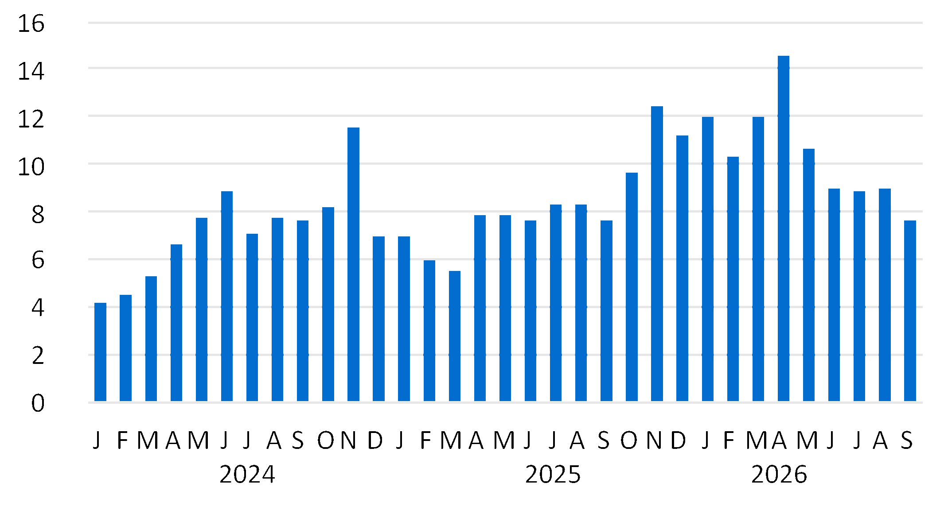
Agency CMBS
30 Year Fixed Rate Pools
Conventionals
30yr 2.0s
30yr 2.5s
30yr 3.0s
30yr 3.5s
30yr 4.0s
30yr 4.5s
30yr 5.0s
30yr 5.5s
30yr 6.0s
30yr 6.5s
Ginnie Mae
30yr 4.5s
30yr 5.5s
Agency Portfolio
UMBS 30yr 5.5 TBA
UMBS 30yr 6.0 TBA
Net TBA Positions
5yr US Treasury Longs
US Treasury Long Positions
Total Portfolio

Common Stock Price ($)
Debt-Equity (1)
Implied Leverage (2)
Liquidity (3) (in millions)
Liquidity as Percentage of Total Capital
Q2 2026 Market Cap (in millions)
Dividend Information
September 2026 Common Dividend
Common Ex-Dividend Date/Record Date
Pay Date
Current Dividend Yield

ARMOUR Portfolio
Composition
% of
Portfolio
Market
Value (in $
millions)
Effective
Duration
ARMOUR Key Data
ARMOUR Portfolio CPR

Portfolio and Key Data as of 08/31/26, except CPR which is as of 09/04/26 or as stated otherwise.

Monthly Update September 2026

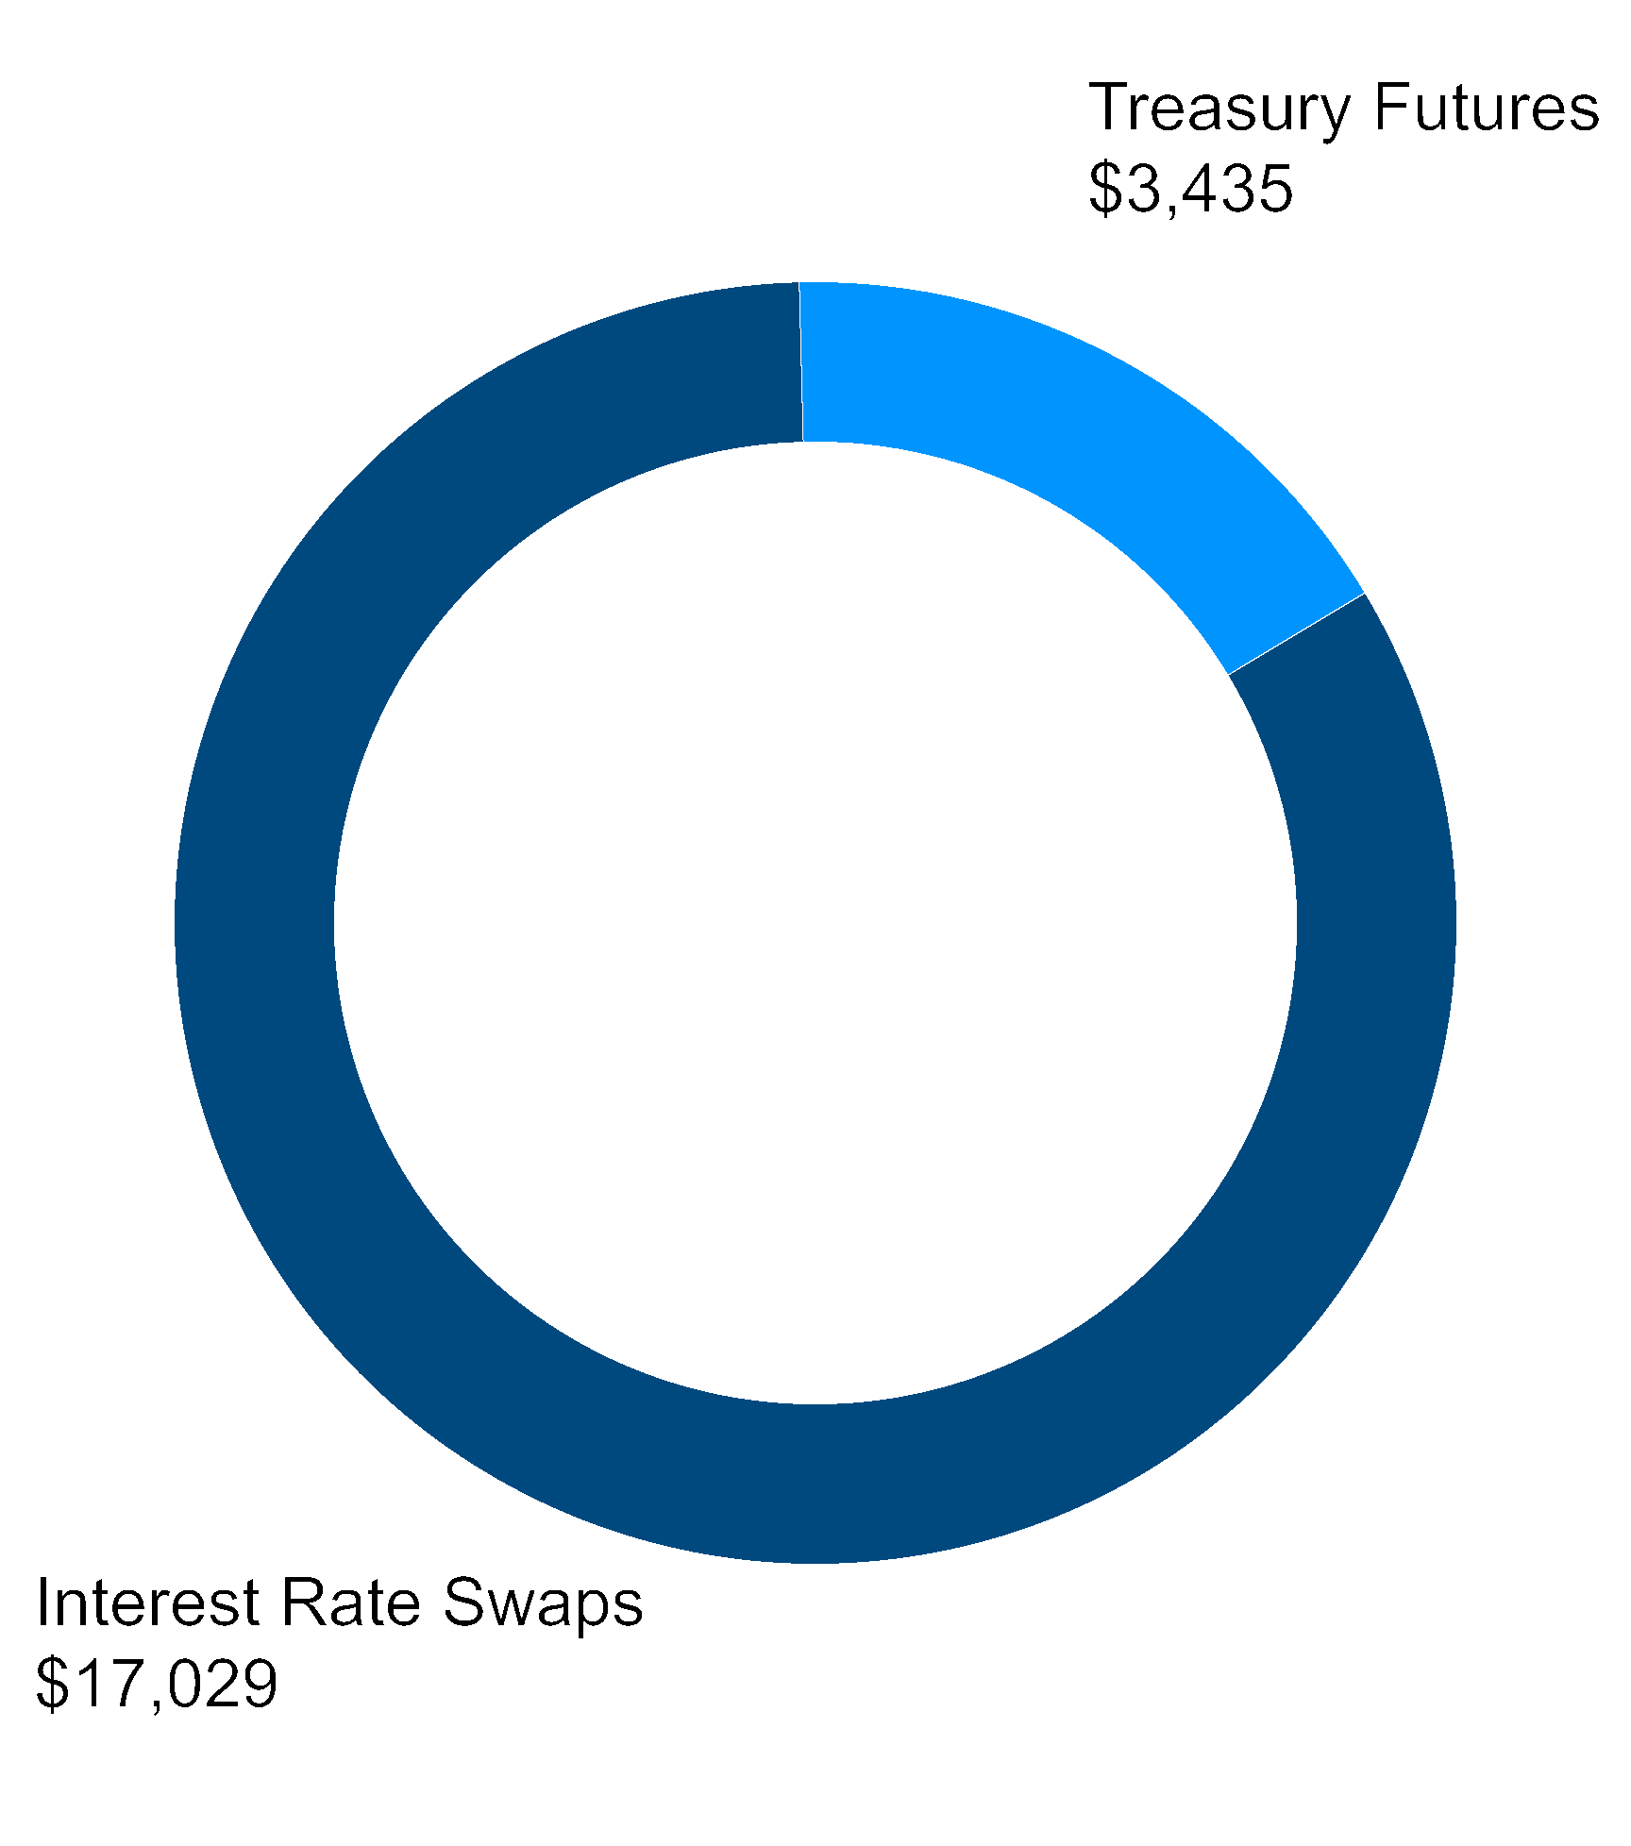
BUCKLER Securities LLC (4)
All Other Counterparties
Total (5)

0-12
13-24
25-36
37-48
49-60
61-72
73-84
85-96
97-108
109-120
>120
Total

ARMOUR Repo
Composition
Principal Borrowed
(in $ millions)
% of Repo Positions
with ARMOUR
Weighted Average
Original Term (days)
Weighted Average
Remaining Term (days)
Longest Maturity
(days)
ARMOUR Interest Rate
Swaps Maturity (months)
Notional
Amount
(in $ millions)
Weighted Average
Remaining Term
(months)
Weighted
Average Rate
ARMOUR Hedge Type Notional (millions) (6)

Footnotes

THE INFORMATION PRESENTED HEREIN IS UNAUDITED AND NOT REVIEWED BY OUR INDEPENDENT PUBLIC ACCOUNTANTS.
AMOUNTS MAY NOT FOOT DUE TO ROUNDING.
will depend on a number of factors that cannot be predicted with certainty and may be materially different from estimates.

Pricing and duration information are estimates provided by independent third-party providers based on models that require inputs and assumptions. Actual realized prices and durations
guarantee future results, levels of activity, performance or achievements.

statements, information and estimates contained herein are based on information that the Company believes to be reliable as of today's date unless otherwise indicated. ARMOUR cannot

This material is for information purposes only and does not constitute an offer to sell, a solicitation of an offer to buy, or a recommendation for any securities or financial instruments. The
forward-looking statements, which speak only as of the date hereof.

ARMOUR assumes no obligation to update the information in this communication, except as otherwise required by law. Readers are cautioned not to place undue reliance on these
Certain statements made in this presentation regarding ARMOUR Residential REIT, Inc. (“ARMOUR” or the “Company”), and any other statements regarding ARMOUR’s future
concerning these factors and risks are contained in the Company’s most recent annual and quarterly reports and other reports filed with the Securities and Exchange Commission.

ARMOUR’s control. A number of important factors could cause actual results or events to differ materially from those indicated by such forward-looking statements. Additional information

looking statements relate to the future, they are subject to inherent uncertainties, risks and changes in circumstances that are difficult to predict and many of which are outside of
looking statements include but are not limited to statements regarding the projections and future plans for ARMOUR’s business, growth and operational improvements. Because forward-
“intend,” “plan,” “may,” “will,” “could,” “should,” “believes,” “predicts,” “potential,” “continue,” and similar expressions) should also be considered forward-looking statements. Forward-

Reform Act of 1995. Any statements that are not statements of historical fact (including statements containing the words “expect,” “estimate,” “project,” “budget,” “forecast,” “anticipate,”

expectations, beliefs, goals or prospects constitute “forward-looking statements” made within the meaning of the safe harbor provisions of the United States Private Securities Litigation

1.Total Repo divided by Shareholders’ Equity.
2.Implied Leverage is Total Repo plus TBA market value net of forward settling trades divided by Shareholders’ Equity.
3.Liquidity is cash plus unencumbered Agency and US Government securities. Excludes any forward settling trades.
4.BUCKLER Securities LLC is an SEC registered broker-dealer and a member of FICC and FINRA that is affiliated with ARMOUR.
5.Repo composition includes funding for US Treasury longs and margin collateral posted to ARMOUR.
6.ARMOUR’s Treasury Futures have a weighted average duration of 10.77 years.

